**Evaluation**

A screenshot of the confusion matrix can be seen below:

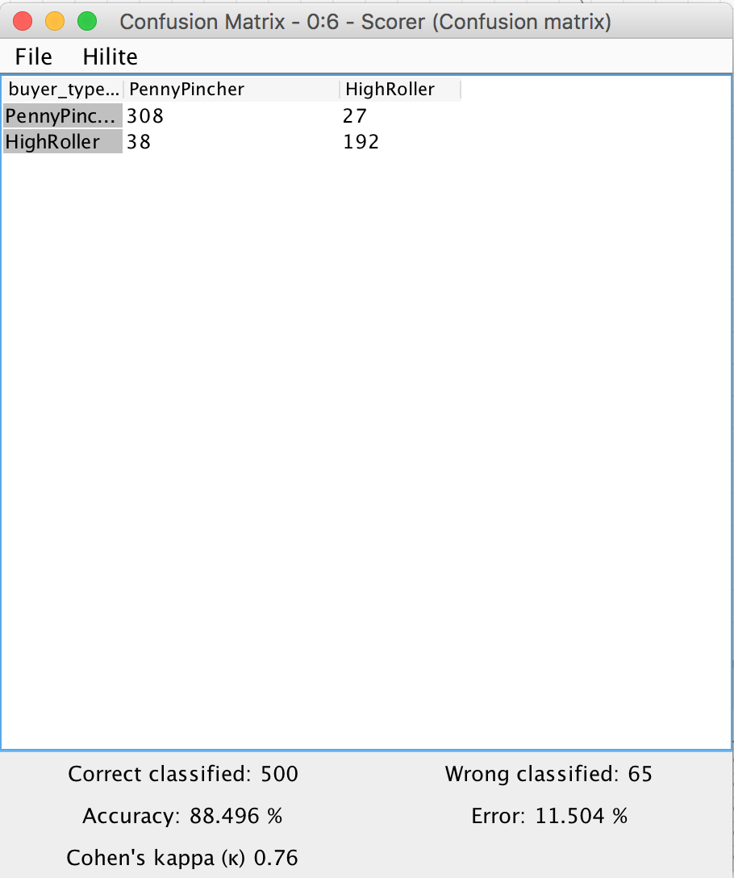

As seen in the screenshot above, the overall accuracy of the model is **88.496%**

**When the buyer type is PennyPincher, the model classified correctly 308 times and incorrectly 27 times. When the byer type is HighRoller, the model classified correctly 192 times and incorrectly 38 times.**